The factors affecting when using social media on students’ life
Module: Academic English and Study Skills (OTHM)

Student Name : Yasalath Gedara Dinaya Madhurya
Student Number : CL/OTHMFL3/11/56

Acknowledgment

Above all, I would want to express my gratitude to our professor, Mrs. Chameera Wijayathunga, for sharing her knowledge with me throughout our lectures in the lecture hall. My parents' steadfast encouragement and financial support are greatly appreciated. My greatest friends, whose help was vital in creating this proposition, have my sincere gratitude.

Abstract
The factors influencing students' use of social media are evident in the research reports that follow. As the Internet and telecommunications technology have developed, social media has become an essential aspect of our daily lives. Social media use has progressively altered and affected all facets of society, but it has had a particularly large impact on higher education. Many studies have been conducted on social media use in higher education; nevertheless, the effect of social media on students' academic performance has not received enough attention, especially in the context of Sri Lanka. In contemporary times, with the Internet witnessing exponential expansion, social networking sites have assumed a key role in the lives of students.

Table of contents

Acknowledgment 2
Abstract 2
Introduction 5
Research Questions 6
Research Objectives 6
Literature review 6
Conceptual Framework 6
Cyber Bullying 7
Health issues 9
Education 11
Gender 13
Age 14
Qualifications 15
Cyber bullying 17
Mental Health 21
References 27

Table of figures
Figure 1 Gender 15
Figure 2 Age 16
Figure 3 Qualifiying 18
Figure 4 Cyberbullying is a significant issue today on internet 19
Figure 5 Social media combat cyberbullying 20
Figure 6 Individuals Online actions get Legal reults 20
Figure 7 Awareness stopping cyberbullying 21
Figure 8 Guardians manage kids online activity 21
Figure 9 Phones harm sleep 22
Figure 10 Internet better health choices 22
Figure 11 Can web aid mental health 23
Figure 12 Does internet helps in healthcare improving 23
Figure 13 Does social media foster student community 24
Figure 14 Social media enhances learning 24
Figure 15 Social media lowers performance 25
Figure 16 Social media makes learning more diverse and varied 25
Figure 17 Social media harms education 26

Introduction
Any media that is shared through social interactions is referred to as social media. Social media, in its simplest form, may be defined as cybernetic and simulated interactions between individuals, groups, and businesses, etc. This involves the creation, sharing, and exchange of data in the form of words, images, and symbols. It involves the process through which individuals engage by sharing, producing, and exchanging knowledge and ideas via online communities and networks, claims.
Philosophy and technologies provide the foundation for social media, which are internet-based apps. Boyd and Ellison argued as a result that social media is based on web-based tools that enable people or groups of persons to create public or semi-public profiles.
The issue of cyberbullying in the classroom is quite important. Cyberbullying, which differs from traditional bullying in that it may occur anywhere and is anonymous, is a significant issue for schools. The reality of cyberbullying is the digital era. It is crucial to comprehend exactly what cyberbullying is in order to handle this issue. Therefore, developing a practical and theoretically valid definition is crucial. The definition of cyberbullying is discussed in this article as a contribution to the body of literature. The special characteristics of repetition, power disparity, aim, and aggression—considered crucial parts of conventional face-to-face bullying—are taken into account in the context of cyberbullying.
The issue of social media's effects on mental health and its importance in the current digital era are introduced in the introductory section. It gives a broad overview of social media platforms' extensive use and the rising anxiety about its consequences on psychological health. The possible harm that social media may do to mental health is examined in this section. It highlights elements that might lead to psychological suffering, including social comparison, cyberbullying, FOMO, and negative self-perception. The section provides pertinent research findings and data demonstrating the connections between using social media and mental health conditions include anxiety, sadness, and poor self-esteem.
the impact of social media on education and adolescents' lives highlights the potential dangers of social networking websites like LinkedIn, Facebook, Twitter, and Orkut on students' futures and careers. While these platforms may be beneficial, they can also be harmful and wasteful, causing students to focus on distractions rather than their education. In today's world that social media has become an addiction for students, teens, and adults. (Serinah, 2019)

Research Questions
What are the factors affecting when using social media on students’ life?

Research Objectives
To find out the factors affecting when using social media on students’ life.

Literature review

Conceptual Framework

Independent Variables Dependent Variables

Cyber Bullying

Education

Use of Social Media

Health issues

Cyber Bullying

Online bullying also refers to cyberbullying and cyber harassment. Due to the developments in communication technology and the rising usage of such tools by young people, it has grown more and more prevalent, especially among teenagers and adolescents. Cyberbullying is the act of someone, usually a teenager, harassing or bullying someone else online, especially on social media sites. In many circumstances, cyberbullying is a continuation of existing traditional bullying. Most often, students who are bullied online have also been bullied in more conventional ways (such as physically or verbally). (Ben-Joseph, n.d.)

There are 10 types of cyber bullying

1.Social Exclusion - A person is excluded from social situations on purpose when they do this. A youngster may be blatantly left out of chats or message threads involving friends they both know, or they may be included in events or gatherings that "everyone" is talking about.

2. Harassment - Bullying and cyberbullying fall under the broad category of harassment, which encompasses many different situations. While harassment is committed when a victim belongs to a protected class, such as a protected class based on race, religion, sex, disability, or other characteristics, bullying still occurs when the victim is physically or emotionally harmed.

3. Outing or Doxing – It is the act of revealing sensitive or personal information about someone without their consent to cause them harm or humiliation. In the case of cyberbullying, doxing might entail exposing sensitive photos of a person without their permission or sharing an individual’s private messages publicly, such as in an online chat group.

4. Trickery - Outing and trickery are comparable, with the addition of deception. Once the bully gets the target's trust, they take advantage of it by nefariously disclosing the victim's secrets and personal data to others.

5. Cyberstalking - Cyberstalking, a particularly serious and potentially harmful form of cyberbullying, is a federal offense that carries a prison sentence and significant fines. Cyberstalking examples include:
1. Making threats via text, instant message, email, or social media
2. Using sensitive photos or information to demand sexual favors
3. Tracking a person’s online movements and actions
4. Posting harassing or threatening statements about a person on social media

6. Fraping -Fraping is a combination of the words “Facebook” and “rape.” Fraping, which is no longer just confined to Facebook, is when a bully takes over a victim's social media account and posts material meant to humiliate or disgrace the victim.

7. Masquerading - Fraping and masquerading go hand in hand. However, masquerading is the act of making a false online identity or profile and pretending to be someone else without that person's permission, as opposed to taking control of that person's account.

8. Dissing - Dissing is the act of a bully disseminating derogatory information about their victim through public posts or private messaging in an effort to harm their reputation or interpersonal connections. In these circumstances, the bully frequently knows the victim personally, either as a buddy or an acquaintance.

9. Trolling - When someone makes offensive or inflammatory comments online, such as in a Reddit thread or a social media group, they are trolling. Bullies who bully others online frequently have no personal connection to their victims and are more interested in stirring up trouble in general.

10. Flaming or Roasting - Similar to trolling, flaming (also known as roasting) is a more direct attack on an individual. Flaming is often defined as the use of vulgar words and derogatory remarks with the aim of intimidating the victim. (Klomek, 2022)

Health issues

Use of social media can impair mental health and result in poor sleep quality. It's linked to anxiety, depression, and low self-esteem.
Nowadays, a lot of individuals have their iPhones as virtual friends. These gadgets employ digital social media networks to notify users of updates regarding friends, favorite celebrities, and major world events. Many people now fully incorporate social media into their daily life. According to Research Centers estimates that 94% of individuals utilize social media today.
Fundamentally, social media is a potent tool for communication that has transformed how people communicate with one another. It expedites how people communicate and share ideas, thoughts, and information over virtual networks. Social media does, however, have drawbacks. According to some data, using it excessively can have a variety of harmful effects on mental health.
The time period corresponds with the increasing use of social media platforms, even though social media may not have had a part in all of these incidents. According to the study, girls who used social media for at least two hours a day starting at age 13 had a greater clinical risk of suicide as adults, but social media use had no effect on the risk of suicide for boys.
For mental health to exist in humans, face-to-face interaction is necessary. Making eye contact with someone you care about is the fastest and most effective way to reduce stress and elevate your mood. The likelihood of developing or worsening mood disorders like anxiety and depression increases with the amount of time you spend interacting on social media rather than in-person relationships. (Zsila & Reyes, July 06, 2023)

Positive effects
Even with its shortcoming, social media is still a useful tool for bringing people and communities together globally.
Many people benefit from social media-based networking within small groups of people. Young people who experience anxiety and poor social skills can express themselves and interact with others through social media. People can meet and connect with like-minded people, which can be especially beneficial for marginalized groups. Connection with friends and family is easy and simple, regardless of physical distance. Young people can showcase their individual talents much easier with social media platforms.

Negative effects
A main fact is that screen time can increase or decrease a child’s weight causing obesity or malnutrition
Social media can exacerbate inferiority complexes. Envy and unhappiness can arise when people believe that their look or way of living does not compare favorably with that of others on social media.
According to a study, excessive social media use makes people feel more alone rather than less. It also stated that cutting back on social media use enhances people's wellbeing by making them feel less alone and isolated.
Social media can also lead to unhealthy self-centeredness, alienation from friends and family, and cyberbullying.

Managing the effects
One way to use social media for good is to:

- Disable data connectivity on smartphones at specific periods of the day, like while driving, working, or attending meetings.
- Disabling data connectivity when socializing with loved ones
- Putting away the smartphone when you go to sleep
- Disabling the notifications to help you ignore the annoying vibrations or beeps
- Restricting your use of social media to computers instead of smartphones (Robinson, 2023)

Education

The rise of technology and social media has significantly impacted students' reading habits, despite the importance of reading for personal growth. The misuse of technology, particularly social media, has led to a decline in reading rates, affecting students of all ages and genders.
Negative effects
Almost all students are spending their time on the internet for non-educational purposes, losing sense of time, and consuming non-educative information. They believe smartphones are easy assimilation tools for reading, but this can reduce assimilation rates and cause disturbances. Students are now seeking information that doesn't add value to their lives, preferring media over reading for pleasure. This has reduced brain development and led to students no longer learning through reading. Students are increasingly relying on online resources, leading to a decrease in the use of libraries and research institutes. This has led to a lack of retentive memory, lazy information retention, and exposure to social vices and pornography sites. This has resulted in students practicing what they see online, which can negatively impact their education.
Furthermore, social media interfered with writing abilities. Students no longer know how to write lengthy essays since they no longer read novels or storybooks that could teach them how to write. The Internet is abundant of short stories and write­ups with loads of abbreviation, and pupils who read all of these will lack the true writing competence. Furthermore, because of the nature of how messages and chats are written, students have developed the practice of writing in shorthand, building incomplete sentences and few lines, which has harmed their grammar, punctuation, communication, and writing skills. Many of them are affected by these acts in class, as well as during exams and assessments. (Chinda, March 27, 2023)

The Positive effects
Social media has several beneficial consequences and implications. For starters, it improves learning and education. Students now have access to many types of knowledge thanks to the Internet. Nothing is unusual to 'google'. The Internet, regardless of how ancient the material is, serves as a searchlight for it. Some information that was previously unavailable in libraries and research institutes is now available online. Many students have benefited from the usage of search engines such as Google and Google Scholar. The world is today a small space where knowledge and information circulate. Students' educational concerns are explored and resolved online with the assistance of online counselors.
Schools now share resources enabling distance learning through social media. Universities offer online courses, reducing travel and risk. Students can study abroad in Nigeria, and assignments are submitted via email. Teachers provide online materials, reducing costs and misplacement, making education easier.
Media exposure allows students to connect with people from around the world, access educational groups, and access to mentors and role models. It also provides opportunities for students to contract industries and companies of interest, and job applications are being made online, enhancing their knowledge and versatility in various fields.
To improve student education, reduce social media usage, moderate access, monitor children's screen time, and seize phones during exams. Encourage educational programs and news, while addressing immoral content. This will improve reading culture and academic progress, while preventing negative aspects from influencing students' education. (Ajay, 2023)
Data Analysis
The questionnaire was distributed using google forms and xxx responses have been collected. The responses are analyzed in this chapter based on the questions asked and the responses arrived

Gender
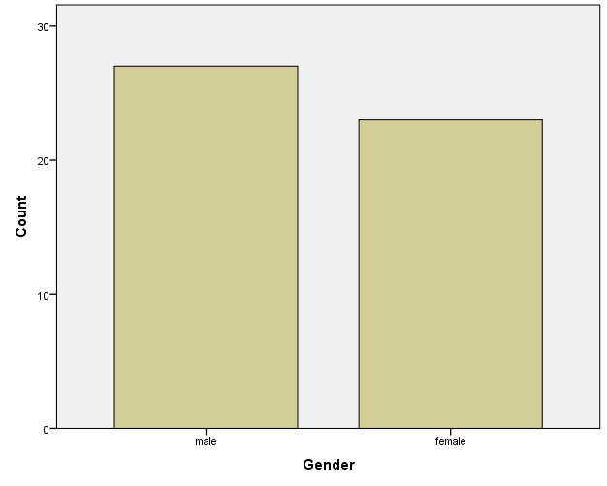
Figure 1 Gender

There were 50 respondents who had answered the questionnaire out of which 27 people were male and 23 were female. It could be seen that more male people have filled the questionnaire. The gender distribution of survey respondents is depicted in the graph as it relates to the factors that affect students' use of social media. Of the individuals involved, 16% identified as female and 34% as male.

The data indicates that there was a clear gender gap in the survey sample, with more men than women represented. The survey's overall findings and conclusions may be impacted by this gender distribution because the experiences and viewpoints of men may predominate. When examining the survey's main focus—the variables influencing students' lives when they use social media—it becomes imperative to take into account any potential gender-specific differences in the responses. Men and women may use social media in different ways and have different tastes when it comes to how it affects their daily lives. Therefore, a more thorough knowledge of these characteristics would be provided by a more balanced gender representation in the poll.

It is crucial to evaluate the poll results cautiously and acknowledge that they can be biased toward the male perspective given the male-majority setting. Future studies might strive for a more equal gender distribution to reduce this bias and provide a more comprehensive and representative examination of the variables impacting students' life when it comes to social media use.

Age
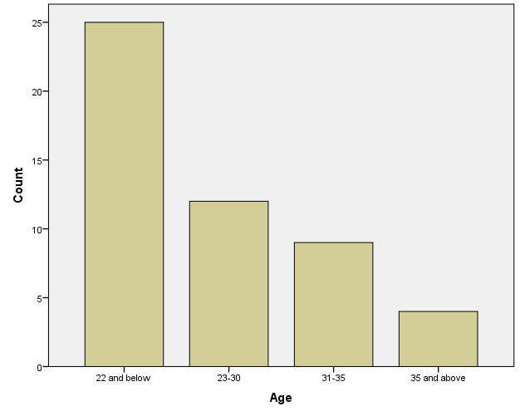
Figure 2 Age
The graph illustrates the diverse impact of social media on students' lives across different age groups, shedding light on the varying degrees of influence and concerns associated with these platforms. The age categories are segmented as follows: 22 and below, 23-30, 31-35, and 35 and above, each assigned a numerical value reflecting the perceived significance of social media's impact.

Among respondents aged 22 and below, a substantial weight of 25 is assigned, indicating a considerable impact on this demographic. This may be attributed to the pervasive nature of social media in the lives of younger individuals, influencing their social interactions, self-esteem, and daily routines.

In the 23-30 age bracket, a score of 12 suggests a comparatively lower impact. This could imply a more balanced approach to social media use among young adults, with a greater ability to manage its effects on their lives.
Surprisingly, the 31-35 age group reports a higher impact, assigned a value of 18. This may be indicative of the evolving role of social media as individuals navigate career and family responsibilities during this life stage.

For those aged 35 and above, the lowest score of 4 signifies a minimal impact. This could be attributed to a more tempered and selective use of social media among older individuals who have developed a sense of digital literacy and discernment.

In summary, the graph reveals a nuanced relationship between age and the perceived impact of social media on students' lives, reflecting the evolving dynamics of technology and its role in shaping the experiences of different age cohorts.

Qualifications
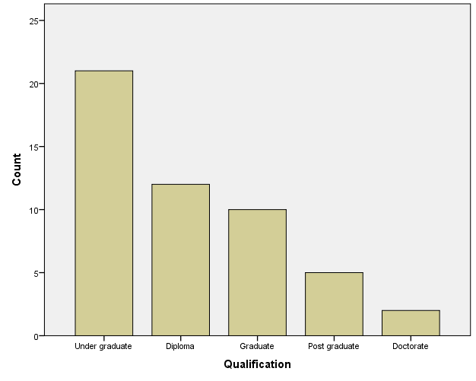
Figure 3 Qualifiying
The graph represents the qualifications of respondents in a survey conducted to investigate the factors affecting students' lives when using social media. The qualifications are categorized into five levels: Diploma, Undergraduate, Graduate, Postgraduate, and Doctorate, each assigned a numerical value indicating the number of respondents within that qualification level.

Among the surveyed individuals, the largest proportion holds undergraduate degrees, comprising 21 respondents. Following closely are those with diplomas, constituting 12 respondents. Graduates represent the third most significant group, with 10 respondents. Postgraduates and doctorates have 5 and 2 respondents, respectively, indicating higher academic attainment among a smaller portion of the surveyed population.
The data suggests a diverse sample with varying levels of educational background, enabling a comprehensive understanding of the factors influencing students' lives on social media. The distribution across qualification levels may influence the perspectives and experiences shared in response to the survey questions.

The study's focus on social media's impact on students' lives is particularly relevant in today's digital age. As social media continues to play a prominent role in communication, information dissemination, and social interaction, understanding the nuanced experiences of individuals with different educational backgrounds becomes crucial for shaping policies and interventions that cater to the diverse needs of students across academic levels. The results of this survey can potentially contribute valuable insights to educational institutions, policymakers, and researchers aiming to address the challenges and harness the benefits of social media in the context of student life.

Cyber bullying
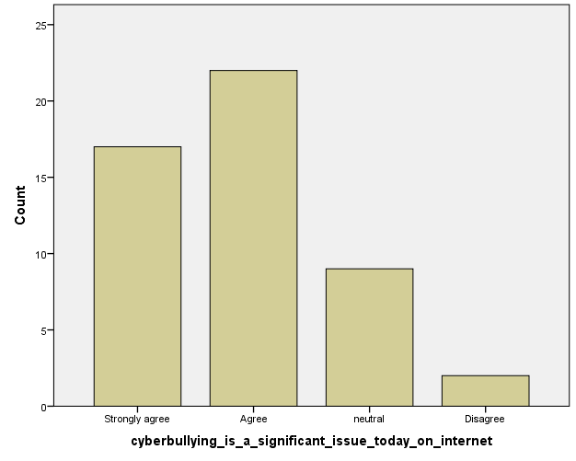

The graph displays respondents' opinions about cyberbullying as a serious problem in the modern internet era, with a particular emphasis on how it affects students' use of social media. 39 out of 50 people strongly agree or agree, demonstrating a widespread worry about how cyberbullying affects students' online safety.

Figure 4 Cyberbullying is a significant issue today on internet
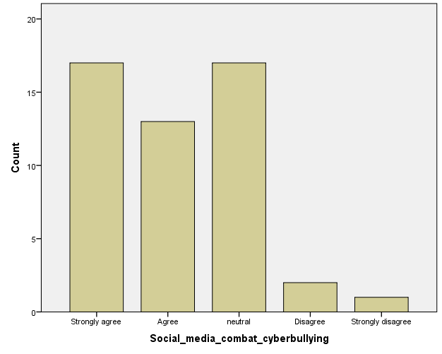
The graph reflects opinions on social media's responsibility for anti-cyberbullying measures. The majority strongly agree (17), followed by agreement (13) and neutrality (17). A small minority disagrees (2), and only one strongly disagrees. The data underscores a prevailing consensus on the need for stricter measures against cyberbullying on social media platforms.

Figure 5 Social media combat cyberbullying

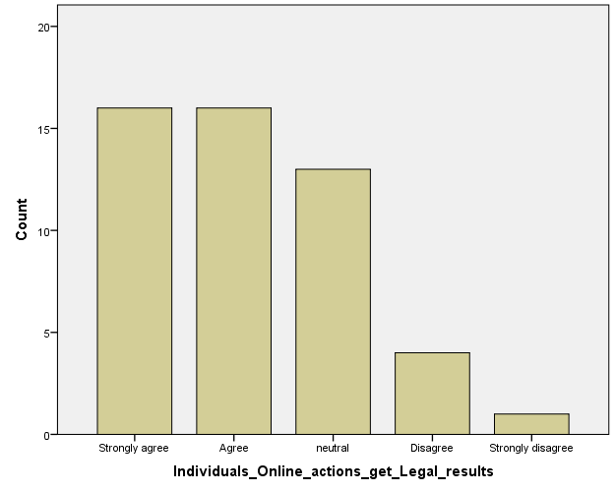

The graph illustrates opinions on whether individuals should be accountable for online behavior and if legal consequences should be imposed for cyberbullying in the context of factors affecting students' lives on social media. The majority (64%) either strongly agree or agree, emphasizing a widespread belief in holding individuals responsible for their online actions.

Figure 6 Individuals Online actions get Legal reults

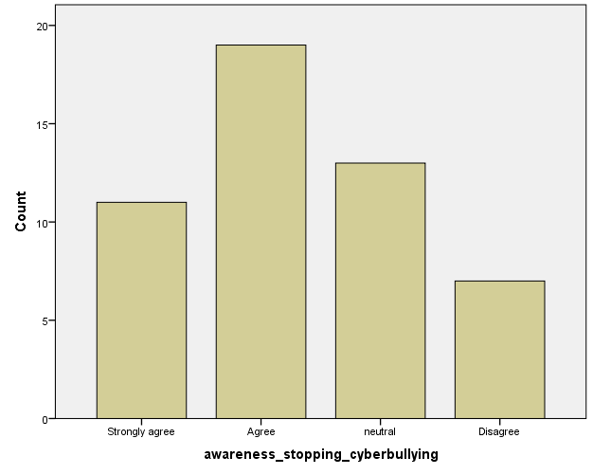
The survey indicates strong support for the belief that increasing awareness and education about the repercussions of cyberbullying is an effective prevention strategy among respondents. The majority, with 30 out of 50 participants, either strongly agree or agree. Only a small minority, 7 participants, disagree with this assertion.

Figure 7 Awareness stopping cyberbullying

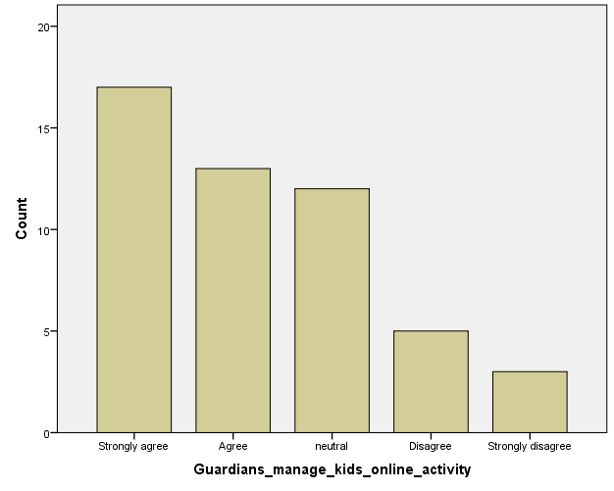
The graph illustrates opinions on parental responsibility in managing children's online activity to prevent cyberbullying. A majority (30) either strongly agree or agree, emphasizing the perceived importance of parental monitoring. A significant number (12) remain neutral, indicating a diversity of views. Fewer respondents (8) express disagreement or strong disagreement with this notion.

Figure 8 Guardians manage kids online activity

Mental Health

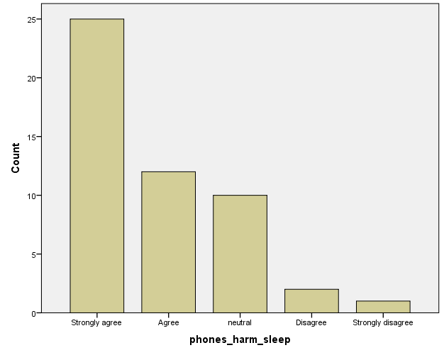
The graph illustrates opinions on the correlation between increasing smartphone usage and its negative effects on sleep quality and overall well-being. A majority, with 25 respondents, strongly agree, while 12 agree. A smaller number express neutral views (10), and only a few disagree (2), with just one strongly disagreeing with the statement.

Figure 9 Phones harm sleep

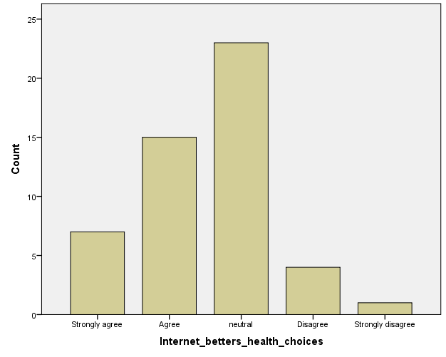
The graph illustrates opinions on the impact of internet health information. A majority, comprising 22 respondents, agree or strongly agree, suggesting enhanced health decision-making. Meanwhile, 23 remain neutral, emphasizing diverse perspectives. A minority of 5 respondents disagrees, indicating some skepticism about the internet's influence on informed health choices.

Figure 10 Internet better health choices
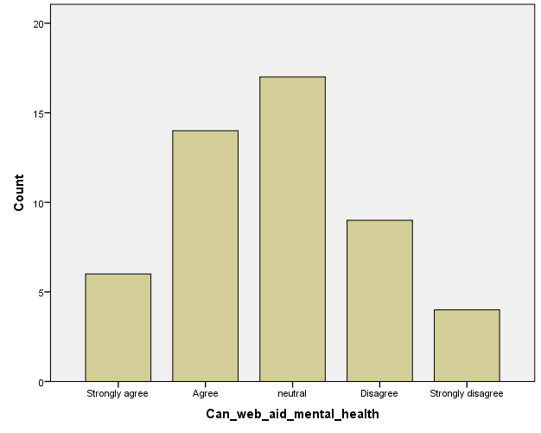
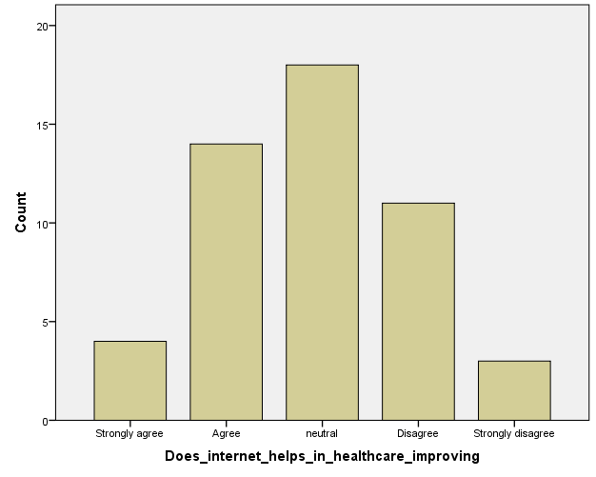
The graph illustrates diverse opinions on the impact of the extensive array of internet-based mental health resources. While 18 respondents remain neutral, 18 agree, with 4 strongly supporting the belief that these resources effectively diminish mental health issues and promote professional care-seeking. Conversely, 17 respondents disagree, with 6 strongly opposing this notion.
The graph reflects diverse opinions on the impact of internet health information. A majority, comprising 20 respondents, agree or strongly agree that online health information enhances informed decision-making. However, 26 respondents express varying degrees of skepticism, with 17 adopting a neutral stance. This distribution highlights the mixed perceptions surrounding the internet's role in shaping health-related decisions.

Figure 11 Can web aid mental health

Figure 12 Does internet helps in healthcare improving

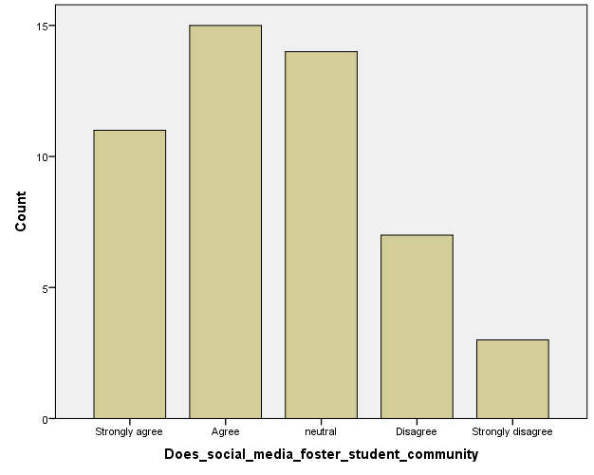
The graph illustrates opinions on integrating artificial intelligence (AI) into healthcare. Out of 50 respondents, 11 strongly agree, 15 agree, 14 are neutral, 7 disagree, and 3 strongly disagree. The distribution reflects diverse perspectives, suggesting varying beliefs about AI's impact on the accuracy and efficiency of medical diagnoses and treatment plans.

Figure 13 Does social media foster student community

Education

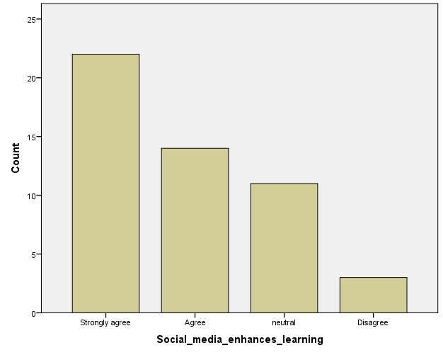
The graph depicts opinions on whether social media enhances learning through student collaboration and knowledge sharing. A majority strongly agrees (22), while 14 agree, 11 are neutral, and only 3 disagree. The data suggests a prevalent belief in the positive impact of social media on educational collaboration and knowledge exchange.

Figure 14 Social media enhances learning

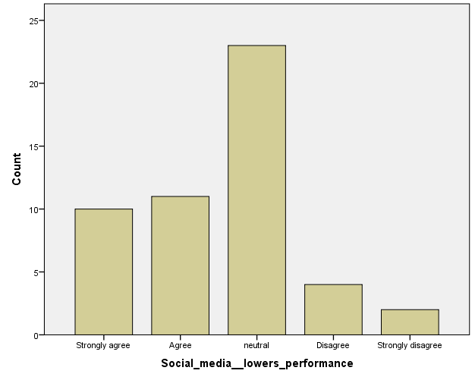
The graph illustrates opinions on whether social media fosters distractions and hampers academic focus, potentially causing a decline in academic performance. Out of 50 respondents, 10 strongly agree, 11 agree, 23 are neutral, 4 disagree, and 2 strongly disagree. The data reflects diverse perspectives on the impact of social media on academic concentration.

Figure 15 Social media lowers performance
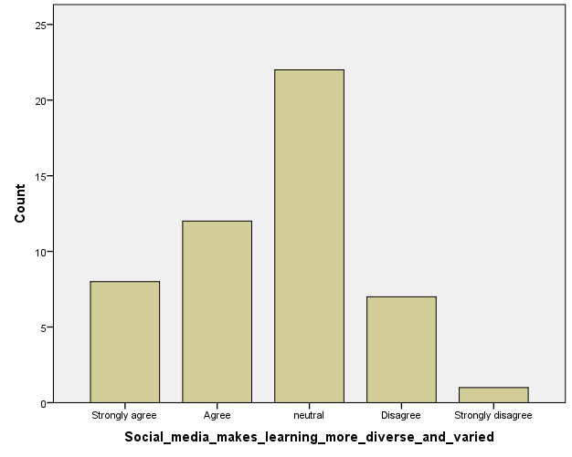
The graph illustrates opinions on social media's role in diversifying educational resources. A majority, comprising 20 respondents, express positive views, with 8 strongly agreeing and 12 agreeing. However, 8 respondents disagree to some extent, and 1 strongly disagrees, suggesting a moderate division on the platform's impact in providing diverse educational content.

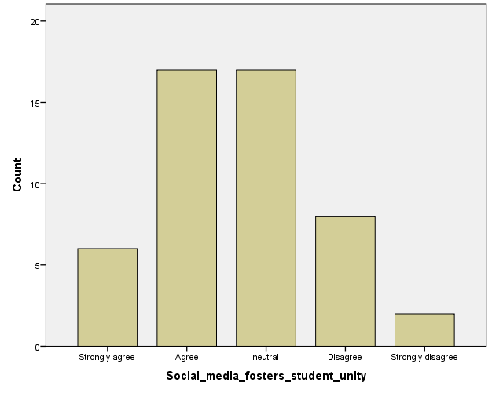
The graph illustrates diverse opinions on whether social media fosters a sense of community among students. A significant 13 respondents strongly agree, 9 agree, and 17 remain neutral. On the contrary, 9 disagree and 2 strongly disagree, reflecting a spectrum of views regarding social media's impact on student support and virtual study groups.

Figure 16 Social media makes learning more diverse and varied

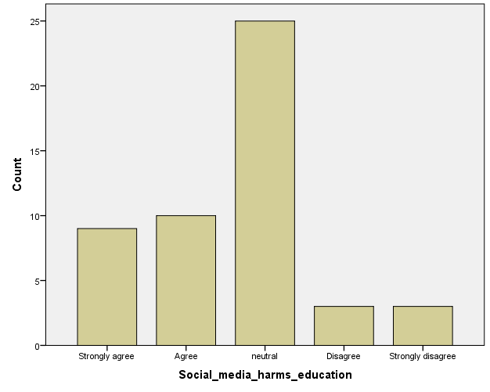
The graph illustrates opinions on whether social media exacerbates cyberbullying, adversely impacting students' mental health and overall well-being, thus harming their educational experience. A majority, comprising 19 respondents, strongly agree or agree, while a substantial 25 remain neutral, and only a combined 6 disagree or strongly disagree with the assertion.

Figure 17 Social media harms education
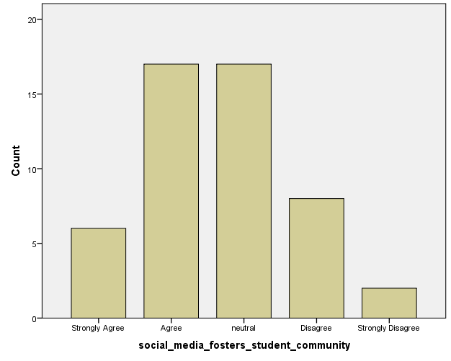
Opinions on whether social media fosters a sense of community and support among students are shown by the bar chart. Most people agree (strongly agree: 6, agree: 17), yet a sizable portion are neutral (neutral: 17). Reactions to the idea are less common (disagree - 8; strongly disagree - 2).

Figure 18 Social media fosters student community

References
Anon., n.d.
A. s., 2023. Positive & Negative Effect Of Social Media On Education. [Online]
Available at: https://www.theasianschool.net/blog/positive-negative-effect-of-social-media-on-education/
[Accessed 13 12 2023].
Ben-Joseph, E. P., n.d. Cyberbullying (for Teens) - Nemours KidsHealth. [Online]
Available at: https://kidshealth.org/en/teens/cyberbullying.html
[Accessed 1 February 2024].
Chinda, J., March 27, 2023. The Impact of Social Media on Education: Opportunities & Challenges. [Online]
Available at: https://drascoedu.com/blog/the-impact-of-social-media-on-students-and-education/
[Accessed 1 02 2024].
Klomek, A. B., 2022. Cyberbullying. Association of Cyberbullying Experiences and Perpetration With Suicidality in Early Adolescence, p. 1.
Robinson, L., 2023. HelpGuide.org. [Online]
Available at: https://www.helpguide.org/articles/mental-health/social-media-and-mental-health.htm
[Accessed 13 12 2023].
Serinah, I. W., 2019. THE EFFECT OF SOCIAL MEDIA AND LIFESTYLE ON CHILDREN’S DROPOUT RATE. International Journal of Business, Economics and Law, p. 1.
Zsila, &. & Reyes, M. E. S., July 06, 2023. Pros & cons: impacts of social media on mental health - BMC Psychology. [Online]
Available at: https://bmcpsychology.biomedcentral.com/articles/10.1186/s40359-023-01243-x
[Accessed 1 February 2024].

Conclusion

In conclusion, the intricate relationship between students and social media unfolds across three critical dimensions: cyberbullying, mental health, and education. The pervasive use of social media platforms offers unprecedented opportunities for connection and self-expression but is not devoid of challenges. Cyberbullying poses a significant threat, influenced by social, individual, and contextual factors. A comprehensive understanding of the nuanced interplay is crucial for effective intervention.

The impact on mental health reflects a dual nature, with positive aspects such as social support juxtaposed against negative consequences like social comparison and sleep disruption. Recognizing these complexities underscores the need for collaborative efforts among educators, parents, and policymakers to foster a healthier digital environment.

In education, social media's influence is multifaceted, impacting academic performance, online collaboration, psychological well-being, and digital literacy. To navigate this complex landscape, tailored approaches acknowledging cultural and societal influences are essential. The synthesis of knowledge presented in this literature review serves as a foundation for proactive measures, urging stakeholders to empower students with resilience, critical thinking, and a holistic understanding of the factors shaping their digital experiences. As the digital era unfolds, ongoing research and collaborative efforts are imperative to guide the evolution of social media's role in students' lives and education.

Recommendation
- Algorithmic Intervention
Implement advanced algorithms and artificial intelligence tools to proactively detect and prevent cyberbullying. Machine learning models can analyze patterns of communication, identify potentially harmful content, and intervene before it escalates. Continuous refinement of these algorithms is essential to keep pace with evolving cyberbullying tactics.

- Incorporate Mindfulness Training
Integrate mindfulness training into educational programs, teaching students techniques for staying present and aware while using social media. Mindfulness can help students develop a balanced perspective, reducing the likelihood of negative emotional responses triggered by social comparison or fear of missing out.

Appendix
As a student regarding for OTHM with ICBT campus Colombo the questioner is designed to gather data to complete the research for which the topic is impact of social media on students’ life

Select your gender
- Male
- Female

Select your age
- 22 years below
- 23-30
- 30-35
- 35 and below

Higher education qualification
- Diploma
- Under graduate
- Graduate
- Post graduate
- doctorate

Higher education

- Do higher education students use social media to improve knowledge?
- Do you agree that higher education students use social media?
- Do you think social media is mandatory for higher education students
- Do you agree social media helps higher education students to find details about their university works?
- Do you agree that higher education students can do their own work without the help of social media?

Students’ habits

- Do you think that nowadays students are addicted to social media?
- Do you agree that social media can create mental issues in students’ life?
- Do you think that social media makes most of the students’ introverts?
- Do you disagree that only few students get addicted to social media?
- Do you agree that parents should stop giving the mobile to student’s hand until they become an adult?
Addiction

- Do you think that people get addicted to social media by few days?
- Do you Agree that addiction is where parents allow the mobile phone to the child’s hand in small age?
- Do you think being addicted to social media is a normal thing nowadays?
- do people feel urges to use social media more and more?
- Do you agree that turn offing social media notification can reduce being addicted?

